Augmenting children's tablet-based reading experiences with variable friction haptic feedback

【Summary】：

Study the impact of tactile e-books on children and adults, and propose how to design tactile e-books based on the tactile sensations they add to the e-books.

【Initial considerations for tactile ebook design】：

**Limit the number of haptic regions on each page**

**Make textures consistent**

**Make textures congruent**

**Use textures with contrasting intensities**

**Use haptics to supplement the narrative**

**Use haptics to illustrate character actions or emotions**

【Experiments】：

Apparatus：TPaD+Google Nexus 7™

Procedure：

Researchers acquainted parents and children with the feel of TPaD and touch display during the initial training.

Parents and children then use TPaD and e-books, respectively, where and what haptics are applied to the storybook pages.

Results:

1. **Selecting and Applying Textures**:

There are practical differences in the way parents and children choose textures and apply them to e-books.

1. **Age Related Conceptual Differences**:

Younger children (3-5 years old, preschool children) choose texture based on their favorite texture or appearance. Older children (6-8 years, grade K-2) clearly indicate the reasons for the choice.

1. **Adult Strategies for Adding Haptics**:

(When children design their own tactile experiences, they usually choose textures based on personal preferences, and parents articulate design strategies that they think can help their children understand books. Therefore, the behavior of adults provides insights into how to design this new media. .)

Three common strategies:

A. Consistent tactile experience across pages

B. Parents focus on using contrasting textures on each page

C. Parents use the sense of touch to highlight or arouse people's attention to the object, action or part of the narrative.

1. **Feedback on Concept of Haptic E Books**:
2. Children are generally positive about the concept of tactile e-books B. However, some parents point out the limitations of digital textures compared to textures in physical books.

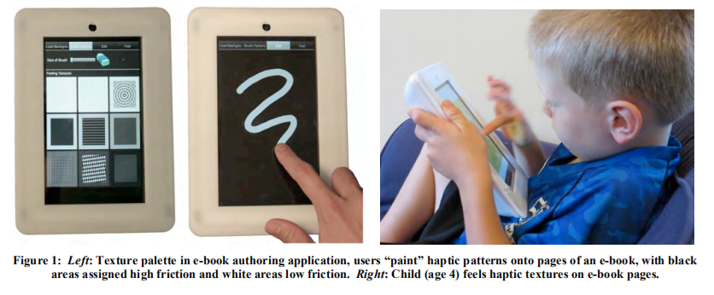

【Important Reference】:

[1] Alam, K.M, Rahman, A., and El Saddik, A. (2013). Mobile haptic e-book system to support 3D immersive reading in ubiquitous environments. ACM TOMM, 9(4).

[9] Marshall, P. Do tangible interfaces enhance learning? In Proc of TEI 2007, 163-170.

[15] Trninic, D & Abrahamson, D. (2012). Embodied artifacts and conceptual performances. In Proceedings of the International Conference of the Learning Sciences, p283-290.